USGS
Download Samples - USGS Water Data for the Nation
- Pulled 1/14/2026
- 01/01/1997 to 01/01/2026
- TSS only
- Saved CSV to Excel, made two tabs – one for original, other for slimmed down columns
- Deleted data
  - Provisional
  - Estimated
  - “Major QC issue”
  - “Minor QC issue” off by 10-30%
- Manually assigned TSS value as ½ of MDL for non-detects
- Changed column names to match AWQMS

NARS – National Rivers & Streams Assessment
NARS Data Download Tool | US EPA
- Pulled 1/14/2026
- Downloaded all water chemistry data for Oregon during survey years 2008-09, 2013-14, and 2018-19.
- Manually merged years for columns of interest
  - Tier I: TN, TP, TSS, Turbidity, Conductivity, pH, Chloride, Sulfate, Chlorophyll
  - Tier II: nitrate, nitrite, silica, ammonia as N, DOC, calcium, magnesium, potassium, sodium
- No MDL listed for many parameters (e.g., TSS). Often a mix of MDLs for same method. Confusing so didn’t alter non-detects unless value was blank (e.g., nitrite 2018-19). Changed values = bolded.
- Changed column names to match AWQMS

BLM – AIM
aim | BLM GBP Hub

COMIDs
- Saved external data sources as CSV and ran through Dan’s COMID batch processing tool. Took around 3 hrs to process USGS’ 19,000 sites.
- Imported CSVs into R and isolated distinct records (i.e., didn’t want to review multiple COMIDs at the same station). Exported as new CSV.
- Made template in ArcGIS for review: NHD medium, NHD high, aerial, labels.
- Made stations shapefiles from CSVs.
- Reviewed each station by clicking through in attribute table. Took ~5 seconds per site, just making sure COMIDs matched.
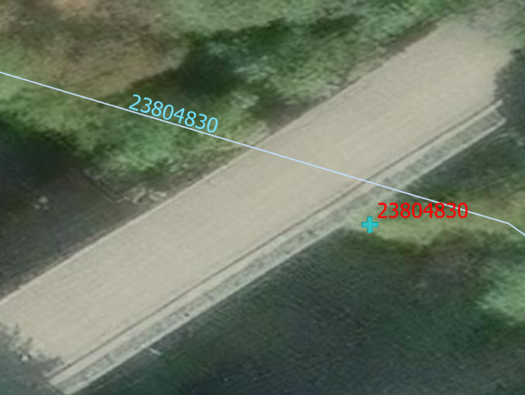
- Made COMID corrections in spreadsheets (green highlights). Used -99999 for high res sites.

